
A collaborative approach to experiential learning across the province
Vision
The premier provincial on-line connection for employers to register their interest in experiential learning.

Mission
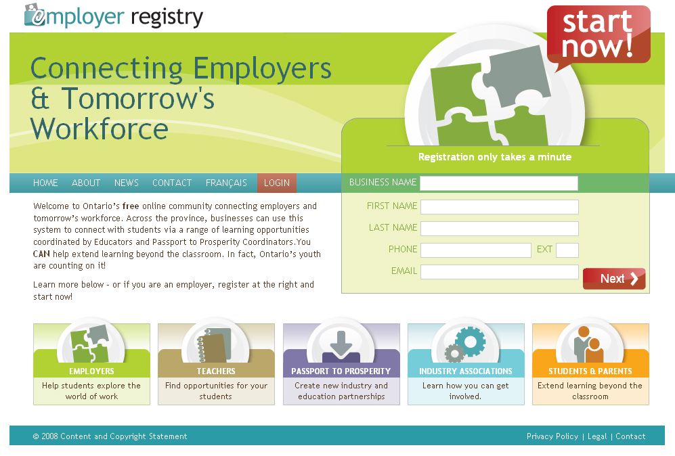
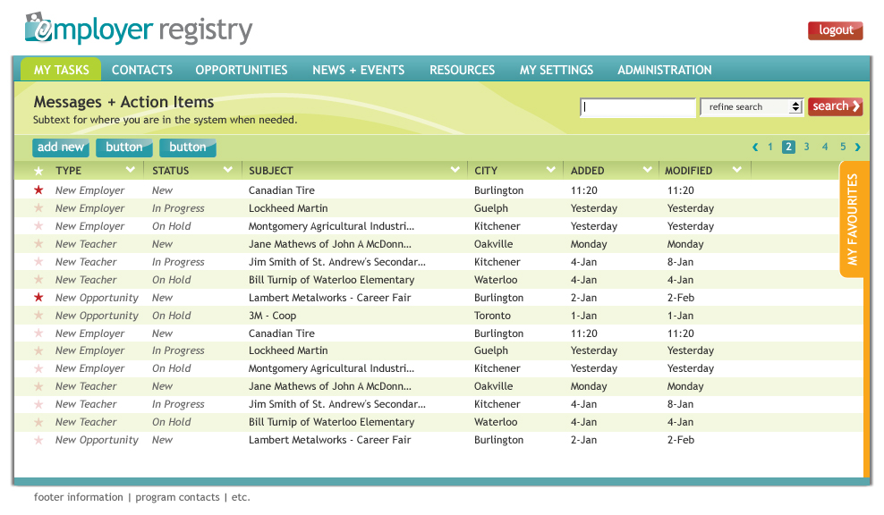
- To connect employers in communities across Ontario with the people and organizations who can help them find or strengthen involvement in new and existing experiential learning programs.
- To provide Passport to Prosperity deliverers, educators and other administrators with fast, accessible and usable tools for managing, developing and tracking relationships with local employers.
- To provide a platform for a bilingual online community focused around programs like the Specialist High Skills Major that will allow for the sharing of resources amongst educators and the promotion of local programs across the province.

Project Components
- A provincial database of employers involved or interested in experiential learning, managed by Passport to Prosperity coordinators and educators in local communities.
- Local information sites that work to showcase local successes and events and allow for the sharing of educational and informational resources.

Consultation and Contacts
Development of the Employer Registry is being driven by the Halton Industry Education Council (HIEC) with support from the Ministry of Education and the Ontario Business Education Partnership.

Questions or comments can be directed to:

Michelle Murray  Passport to Prosperity Coordinator  905-634-2575 ext. 12 mmurray@hiec.on.ca | Matt Elliott  Communications / IT Admin  905-634-2575 ext. 18 melliott@hiec.on.ca
Benefits of using EmployerRegistry.ca
For Employers:

- One starting point for involvement in experiential learning
- Ability to easily offer new forms of learning opportunities for students and manage existing opportunities
- Gives immediate clarity to a single point of contact locally
- Can access up-to-date information on learning programs in Ontario
- Forum to spotlight their involvement in helping to define tomorrow’s workforce

For Teachers:

- An unprecedented level of access to a greater variety of useful employer information, allowing for new opportunities for their students
- One consistent database across all communities, working as a central place for their student connections
- Ability to upload and share student and employer success stories, and share resources with other teachers
- A system developed with a strong emphasis on usability and meeting the day-to-day needs of educators involved with experiential learning

For Passport to Prosperity deliverers:

- A free online system built using cutting edge web technology
- Use of specialized processes and database tools on the back-end that will allow for a greater range of stored employer information and instant custom reporting
- Immediate access to new local employers who have indicated their interest in programs
- Ability to share resources with educators

For Industry Associations / Sector Councils:

- An intuitive online community allowing easy sharing of resources and partnership opportunities related to experiential learning opportunities, advancements in education and HR information
- One-step connections with employers across the province
- Content delivery messaging system bringing targeted news and information from the Ministry of Education & education partners across Ontario

For Students & Parents:

- A rich resource area devoted to answering questions about learning opportunities
- Local sites spotlighting success stories from both the prospective of student and employer
- Intelligent and contextual connections between other key provincial resources, such as the Ontario Skills Passport





- An easy-to-use resource to keep up with the latest news and information on experiential learning and education at the local and provincial level

